Nick Cheepchiewcharnchai

Crosby Merch website

Table of Contents

Analysis 3

Identifying problem 3

Project description 3

Stakeholders and interviews 4

Justifications of how the solution can be solved by computational methods 8

Research 10

Current solution 10

Similar solutions 11

Method of payments 16

Hardware and Software (hosting website) 18

Hardware and Software requirements 19

Hardware Requirements 19

Software Requirements 19

Solution Proposal 20

Features of solution 20

Limitations of solution 20

Success Criteria 21

Admin Criteria 21

Customer Criteria 21

Design 22

Top Down Design 22

Detailed Flow Diagram of Website 23

Entity Relationship Diagram 24

Tables 24

Table Users: 24

Table Order: 24

Table Order Contents: 24

Table Items: 24

Development 26

Testing 27

Evaluation 28

# Analysis

## Identifying problem

Recently, Crosby house has come up with ideas of some merchandise which we would like to sell to the pupils within the house. However, we do not actually have a proper system set up for buying and selling them yet. It will be confusing and hard for the person in charge to create and send out a form before finally being able to go through the results one by one only after making sure that everyone has filled in the form. We are also hoping that we will be able to add more items to the collection of merchandises in the future. This will result in a more complicated and longwinded process to deal with over time, due to the need for someone to physically process the data.

## Project description

I intend to create a shopping website for pupils to buy the house merchandise. They will be able to choose the item, quantity and size (when available) that they wish, these items will be added to their ‘shopping cart’ before confirming purchase at the checkout. I want the ‘admin’ of this website to be able to add new items or remove existing items to the merch list at any point. They should easily be able to see what items each person had bought from this website, including any details (quantity & size).

## Stakeholders and interviews

In this section I will be interviewing my stakeholders using a set of questions that I have made to help me to design a website that will fit their needs. The questions are as follows:

Questions for Admin

What makes a good merch selling website?  
 - Does the aesthetics of a website affect your experience?  
 - What types of devices should the website be compatible with?  
 - Which pages of the website need the most attention?  
 - What key information/features should be on the homepage

What are the current problems with the current solution?  
 - Does the current solution function as it should?  
 - Have you had any negative experiences with the current solution?  
 - What do you think is currently missing from the current solution?

What functionalities are needed for those using the website?  
 - What will customers need to be able to do?  
 - What functionalities will the admins need?  
 - How will the system of the website work?

Questions for customers

What makes a good website for a restaurant?  
 - Does the aesthetics of a website affect your experience?  
 - What types of devices should the website be compatible with?  
 - Which pages of the website need the most attention?  
 - What key information/features should be on the website?

What are the current problems with the current solution?  
 - Does the current solution function as it should?  
 - Have you had any negative experiences with the current solution?  
 - What do you think is currently missing from the current solution?

**Current Head of house, Admin – Julian Lee**

As the head of house is it Julian’s responsibility to gather everyone’s order and process them. This is why he will be a good stakeholder for this project, acting as the admin of the website. He will be able to use this website to hopefully make his job at gathering orders from everyone easier.

Does the aesthetics of a website affect your experience?  
 “Definitely, I think that the aesthetic of a good website should attract the customer to be more likely to buy our merch. I want the website pages to be able to complement and enhance the aesthetic of the merch itself. However when talking about aesthetic of the website on admin’s side, I don’t think that it matters that much, as long as the website is laid out so that it is easy to use.

What types of devices should the website be compatible with?  
 “I want the website to be compatible with my laptop since that is when it is easiest for me to do my work. My phone tends not to be used for work so I don’t really need it to work on the phone, I don’t mind if it works on the phone as well or not because I will most likely not be using it on my phone anyways.”

Which pages of the website need the most attention?  
 “I think that the page which will display all of the merch will be the most important, as that would be where the customers are first introduced to each merch items. If they are attracted to the merch from this page in the first place then it will be likely for them to buy the merch.”

What key information/features should be on the homepage?  
 “I do not really think that a home page is important for this merch website, as long as the merch display page is attractive, then that page can act in itself as a homepage to welcome the users.”

Does the current solution function as it should?  
 “The current solution works fine, however it does not provide the aesthetic and description of each items like I would prefer it to.”

Have you had any negative experiences with the current solution?  
 “When I have to collect and process the data of the orders, it was really hard for me to keep track of who wants which item. I also had the problem of people sending in their order at different times which made me forget which ones I have already processed and which ones I haven’t done yet, it was very time consuming to have to try and figure out what has been added to the list of orders and by whom. Another problem is that the form that is sent out only allows one reply from each person, this means that once someone has sent their form, they cannot change their mind to get more/less items. That means that people will have to talk to me in person and it is quite hard to keep track of all of those requests.”

What do you think is currently missing from the current solution?  
 “The current solution is a Microsoft forms, therefore when I look at responses from each person it will show up with their email address, which I may not be familiar with each person’s email address. This meant that I had to spend extra time to work out who the order actually needed to made for, slowing down he process even more.”

What will customers need to be able to do?  
 “Customers should be able to view all the merch that is available to them and choose which ones they would like to order. They should be able to place multiple orders and at any time that they would like.”

What functionalities will the admins need?  
 “I would like the admins to be able to create and accounts, so that it is easier for me to remember names instead of emails. I would also like to be able to view each orders that has been made and who is was made by, and show if the order has been processed or not. Apart from adding and deleting accounts admin must also be able to edit the available merch and put a front and back picture of the merch on the website.”

How will the ordering system of the website work?  
 “Once the pupil places an order, I’ll be able to see the details of their orders and that will allow me to make a list of all the merch that is needed. I should be able to check that a transaction has been made and I will then get the orders ready. After everything is done I should be able to mark the orders of as finished.”

**Pupil of Crosby House, Customer – Genta Yamanouchi**

As one of the pupils in Crosby house, Genta will be a good stakeholder for this project because he will be the user of this website. In particular he has already ordered two merch items which means that he has used the ordering form beforehand and will be able to judge the difference between the existent solution and the new solution.

Does the aesthetics of a website affect your experience?  
 “Yes it does. I find that a website that look appealing to me makes me want to buy from it more. Probably because if the quality of the website is high, then most likely the quality of the merch will also be high.”

What types of devices should the website be compatible with?  
 “I have tried to do online shopping on my phone before but I found that it was too inconvenient, the picture were too small and I was only able to see one item at a time as I was scrolling down, which is why I always do my online shopping on my laptop. I also find that the only time where I actually have time to properly browse for items is when I am on my laptop.”

Which pages of the website need the most attention?  
 “I think that when I look at a shopping website, the most important page is the item browsing and individual item displaying page. This is because those pages are where I will actually make my decisions of which items I will actually want to buy. The browsing page lures me into a specific item, and on it’s specific page, the details on the items will truly let me decide if I want to buy it or not.”

What key information/features should be on the website?  
 “When it comes to a shopping website I think that the ability to be able to browse items and see the items in the basket before I checkout is very important. It is also important for me to be able to see the order that I have made, and the item that I am waiting for. Since they are all important aspects of a shopping website, I really want to be able to move from one page to another very easily.”

Does the current solution function as it should?  
 “The current solution works, but not very well. It currently isn’t very attractive and the Microsoft form feels so far away from being a proper selling mechanic for the house merch.”

Have you had any negative experiences with the current solution?  
 “It doesn’t allow me to buy more than one of the same item, which I had wanted to do. It was also kind of hard to browse and choose the items because of the way Microsoft forms lays it out.”

What do you think is currently missing from the current solution?  
 “I think that the biggest issue that the current solution has right now is the browsing mechanic, as it is very inefficient. It would be helpful to also have some kind of total so that I know how much I am spending without having to calculate it myself. And something that isn’t really a problem but would really contribute to my experience of buying the merch is to have the buying process by aesthetically pleasing.”

**Conclusions made from interview:**

From the interviews with my stakeholders, I now have an idea of what I should be including into my website, both for the functionality of the admin and the customers.

On the management side of the website:

* No need for aesthetics, because efficiency in functionality is more valued
* Need to be able to work on laptops/PC
* Need to be able to add and remove users
* Need to be able to add and remove merch items, being able to insert the front and back pictures for each item
* Need to be able to see contents and details of each orders made by each user
* Need to be able to see and change the processing status of each item in and order

On the customer side of the website:

* The website must be aesthetically pleasing
* Need to be able to work on laptop/PC
* Need to be able to easily browse through all merch items
* Need to be able to place multiple orders
* Need to be able to choose size and quantity of each merch item before adding to basket
* Need to be able to see the total cost of the basket
* Need to be able to traverse between basket and merch display page
* Need to be able to see all orders made and see its processing status

## Justifications of how the solution can be solved by computational methods

This problem will be well suited for a computer since the data can easily be entered and processed. Because there will be a lot of data that needs to be processed (e.g. total cost for each person, total number of each merch in each sizes that needs to be ordered and for who), the computer will be able to accomplish these tasks much faster than humans. From the side of the customers, it allows convenience for them to be able to do the online shopping from anywhere and at any time, which gives them more freedom in browsing and selecting product. It will also allow many people to be able to browse and order the merch at the same time.

**Thinking ahead**

The inputs I will need for my solution to work, include customer data such as their login details of their school system, which will be collected manually by us to be used as the login for this website. Additionally, data of merch items will be needed to create the list of clothing on the website. Input will also be required from admin to sign orders off when they have been completed, so that the process of checking orders off orders can be ran smoothly.

The outputs my system will give include the total cost of a the merch purchased. Customers may also have an online receipt as an output (showing the total amount of money that they spent). The system will also display the status of each item (e.g. ordered, received, completed).

My website may potentially have reusable components. For example, the CSS of my website could be used across multiple pages of my website (homepage, shopping page, checkout etc.) as it is logical and aesthetically pleasing that each page of my website follows the same colour scheme and design features.

**Thinking procedurally**

I am breaking up the problems into smaller steps so that it will be easier for me to come up with many little solutions that will join together to solve the entire solution. The problems are as follows:

Placing an order:

* The customer should be able to login
* The customer needs to see a list of all the merch
* The customers should be able to add merch items into their basket
* Customers need to make payments for their orders

Preparing an order:

* Admin needs to be able to see the orders placed by all end users combined into one
* The admin need to be able to sign off orders once they are complete
* Orders that are signed off should be removed from the display after a certain amount of time.

Delivering an order:

* Admin need to know which belong to which individual end user

**Thinking logically**

Branching and looping will be needed for some aspects of my solution. For example, once a customer has added an item to their shopping cart, they can either choose to loop back to browse for more items, or they can choose to proceed to checkout and pay to confirm purchase.

Start

## Research

### Current solution

Currently, the house merch system is ran using a Microsoft forms which lists each item and size individually. It is quite time consuming for Julian to have to look at what each person has ordered and then to write them down one by one. It is also an inconvenience for the pupil since they have to go through the entire list of items just to look for one that they actually wanted to buy. Although it is still quite straightforward since there are still only 8 items, but as we go on and there are more and more merch then it will grow to become a big problem for both Julian and all of the students.

**limitation of current solution**

Although this is a working solution, it is not very efficient for both the admin or the customer. I have listed some limitations of using a Microsoft forms below:

Basic customisation options  
Whiles Microsoft forms allows for a certain degree of customisation in terms of design and layout, its options are relatively basic compared to a proper e-commerce platform that offer extensive customisation to match the brand identity and improve user experience. Since the form only allows the pupil to choose a size of the item that they want, it means that they are only able to get no more than one of each item from the website.

Form can only be used once  
Once the form has been summited, the pupil cannot go back to change what they have submitted. Or even to look at their response. Not being able to have access to the form once it has been summitted means that pupils will only be able to buy merch once, if they change their mind and decide that they want to buy another item they that will not be possible for them. This also means that Julian will have to create and post a new form every time a new item has been added to the list of existing merch.

No shopping cart functionality  
The lack of a shopping cart ability may make it hard for the pupils to keep track of which item they had chosen to buy. This will become a big problem and waste of time when the list of merch has grown significantly.

### Similar solutions

Similar solution 1 : H&M website (men’s section)

This is the display page of items that are sold by H&M for men

Features identified:

* Allows you to search for items quickly and easily by clicking on the navbar located on the left side of the screen, bringing you to a different page with only the items mentioned
* Allows you to like each add item to ‘favourite’ by clicking on the heart on each photo of the item, which can checked by the navbar at the top of the page
* Each item shows you the name and the price of the item as well as the colour that they are provided in
* Has arrows on the photos to allow you to look at other photos of same item without having to click onto the page of the item
* A screenshot of a phone

  Description automatically generatedAllows you to view items in different sort orders: recommended, Newest, Lowest price, Highest price
* Has a filter that allows you to only search for items which fits a description that the want:

This is the display page of the item once you click onto them

Features identified:

* Scrolling up and down the page will allow you to see the different photos of the item on the left side of the screen whilst the ‘add to cart’ is fixed onto the right side of the screen
* You can choose which size you would like from the selection that they offer
* There is an accessible size guide to the right of the size selections
* You can check the details of the item under the ‘add’ on the bottom right of the screen: Description & fit, Material, Care guide
* A collage of clothes

  Description automatically generatedA pair of pants and socks

  Description automatically generatedOnce you scroll to the bottom of the page you will be able to locate a ‘style with’ section, suggesting you some other items that may go well with the one you are currently browsing, you can traverse left and right on this section to see more options
* Beneath the ‘style with’ section there is a ‘Others also bought’ that shows you which items were other people tend to buy together with the one you are currently browsing

This is the sign in page for the H&M website

Features identified:

* Accessible on the navbar at the top if every page
* A simple popup page that does not require you to be redirected to a different link
* Can choose to show password but otherwise would be hidden by replacing each letter with indistinguishable dots.
* Has a ‘Remember me’ checkbox which allows you to be automatically signed into the website once reopened through the same device
* Has a ‘Forgot password?’ to allow you to change/ recover your password when forgotten
* When incorrect login details has been entered, an error message is displayed in red

This is the ‘Shopping bag’ page which lists your item before you checkout and pay

Features identified:

* Shows pictures and details of each items (e.g. name, individual cost, size, quantity, total cost)
* Allows the user to get rid of an item in the basket just by clicking the bin icon located on each of the items
* Shows the applicable discount on each item, on the picture of the item
* Shows the total cost of the order on the right, directly above the checkout button
* Shows the methods of payments available to be made by the customer

Similar solution 2 : Etsy (setting up a shop)

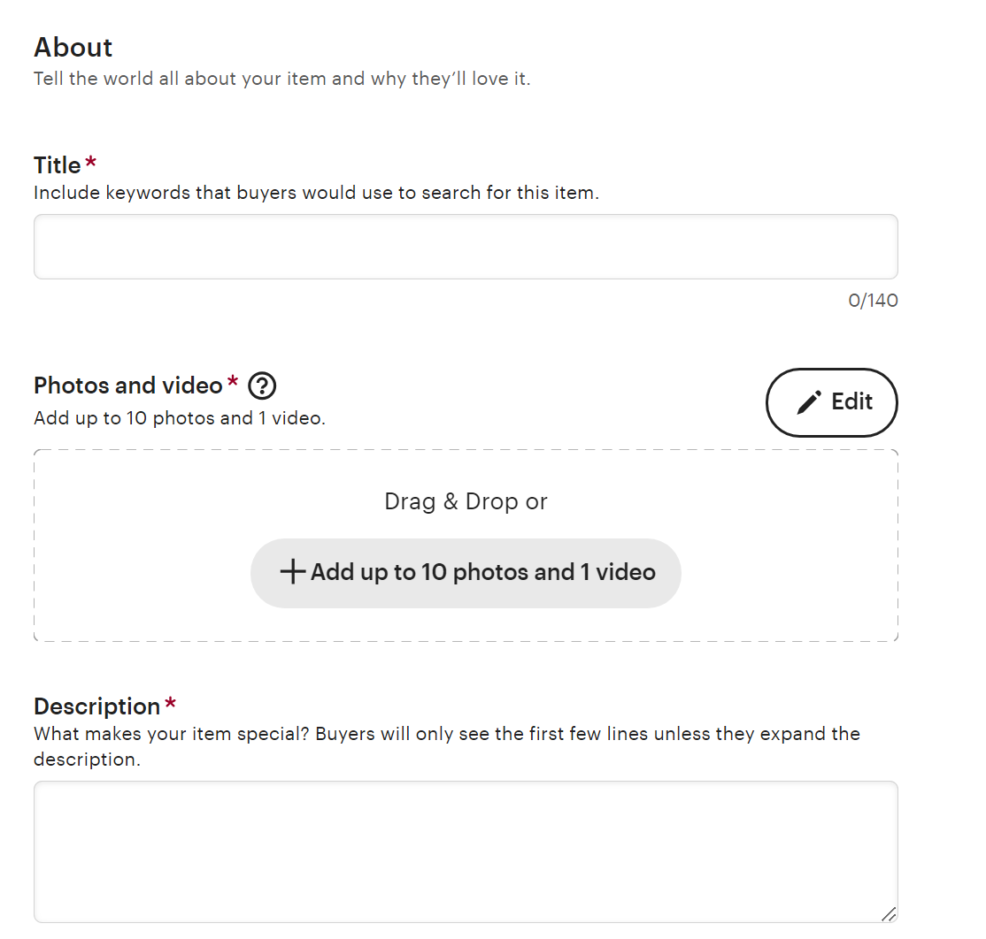In this section, I will be looking at the process of adding an item onto an online shop in Etsy, so that I can know what inputs are asked for in the process of adding an item and whether they are optional or not.

* Name of item (required)
* Add photos and video (at least one required, maximum ten photos and one video)
* A white background with text

  Description automatically generatedWrite a description of the product (required)
* 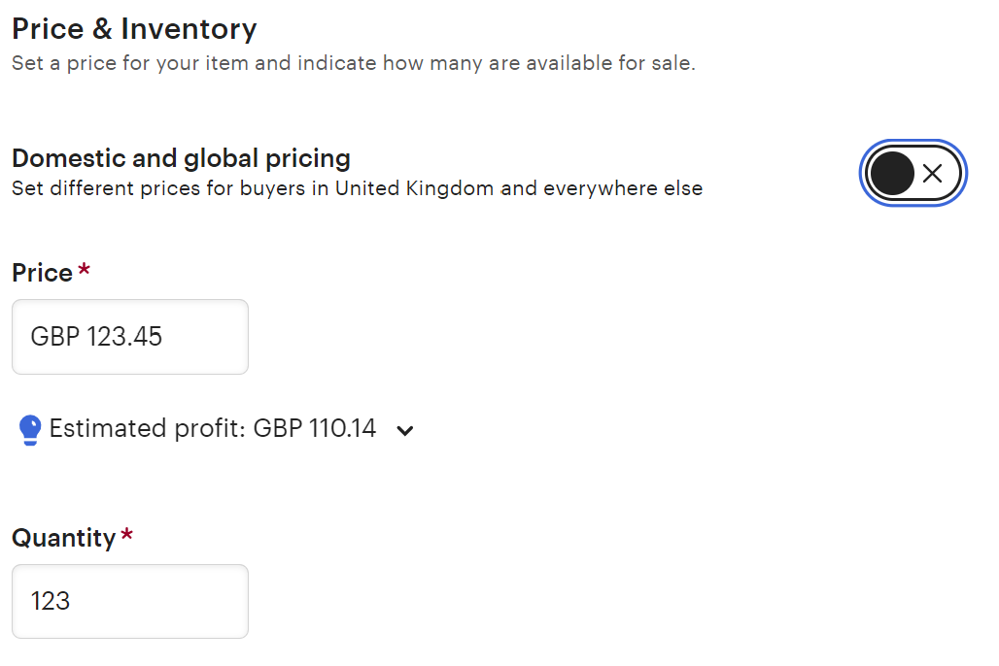When the photos are added, a thumbnail must be chosen from one of the entered photos
* Price per item (required)
* 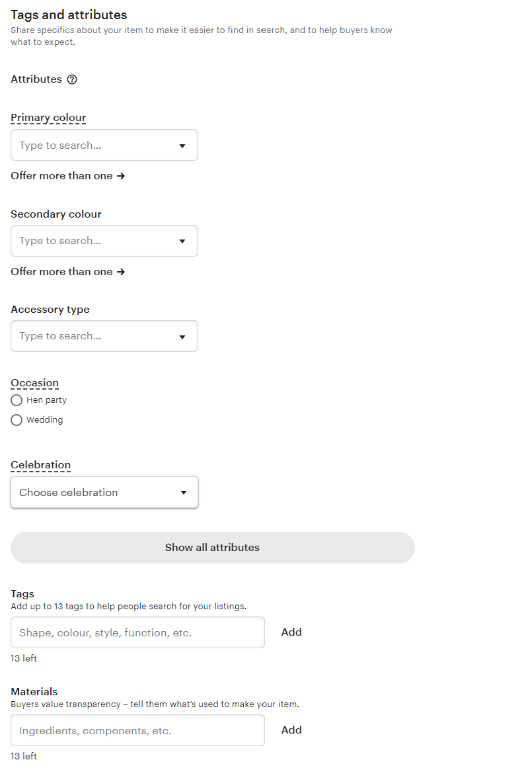A screenshot of a computer

  Description automatically generatedQuantity of stock (required)
* Colour of the item – primary and secondary (not required)
* Item tags, keywords, to help searching for item easier (not required)
* A screenshot of a web page

  Description automatically generatedMaterial of item used for information provided to customer (not required)
* Whether or not the item is physical or digital (required)
* A screenshot of a box

  Description automatically generatedThe item category (required)
* Information on how item will be delivered (required)

### Method of payments

In this section I will research the potential methods of payment that I can use for my project.

**Credit/debit:**

Pros:

* Convenience for customer – Very easy for pupils to make transactions since they just have to enter some card details
* Convenience for admin – The admin will have to do no work in checking that transactions are successful since that can be done by the computer itself
* Speed of transactions – The transaction requires little to no time to be sent through, meaning the purchase can be confirmed really quickly
* Recurring payment capability – If card details are saved onto their device then it will be easy for a pupil to purchase from the website easily every time

Cons:

* Safety of card details – I am not familiar with creating a system online that will take the card detail from someone and making a transaction, this may lead to safety issues for the students cards details
* Purchase confirmation (OTP) – To ensure that the purchase is being made by the owner of the card, an OTP must be used to confirm. I am not familiar with how it will work and how to incorporate messages through phone numbers. Apart from this pupils in the 3rd-4th form does not have access to their phones which means that they will not be able to access their OTP number.
* Availability of card – Although most pupils will have access to a debit card, some may not, and it is unfair if someone without a card would like to purchase the merch.
* Technological illiteracy – Some pupils are still not used to making purchases online since they are still young. They may be scared away from making purchases even though they might want to get the merch.

**Bank transfer:**

Pros:

* Convenience for customer – Very easy for pupils to make transactions as long as they have a bank account. The process of transferring money trough bank accounts are relatively simple.
* Pay by parents – if a student does not have a bank account, the transfer can also easily be done by their parents in their stead.
* Low safety risk – I will not have to be scared of security problems like for a card detail which may be leaked onto the internet.
* No need for a system to be set up – Since I am not in charge of the bank applications, it means that I will not need to set up any kind of system in terms of transferring money from one to another.

Cons:

* Delay of transactions – Transactions may not be instant, sometimes taking up to days before they are cleared, which may delay the confirming process of the purchase.
* Transfer fees – Money transfers from one bank to another may have transfer fees. The transfer fees will differ for each bank which is unfair towards the pupils, especially for overseas students.
* Human error – being in a boys boarding house, sometimes pupils are not very cautious and may transfer money to a wrong account number. In that case there is nothing that I will be able to do for the money that has be incorrectly transferred.
* Human management – the admin is required to check the bank balance every time someone makes a transaction, they also need to check which transactions are made by who by looking at account numbers, and if the amount of money that is received is correct. Only then will the admin be able to confirm the purchase made by the pupil.

**House bank:**

Pros:

* Convenience for customers – pupils will easily be able to put the amount of money spent onto a bill that will be retracted off their house bank after the purchase has been confirmed.
* Money flexibility – House bank allows students to go into debt which can be paid of by cash/money transfer at a later time. This allows for pupils to be able to make purchases when they don’t have money on them, but can pay back easily at a later time either by them or by their parents.

Cons:

* Consent of purchase – Student may use house bank to buy merch without their parents’ permission, this may cause issues from the parents perspective, since their child is spending their money without permission
* Debt collection – When many pupils go into a lot of debt, it starts becoming an issue to get everyone to pay it off. It will be an inconvenience for the admin of the house bank.

**Cash:**

Pros:

* Convenience for customers – cash is easily accessible by everyone, and is a form of payment that is accepted by people. It does not create extra steps for pupils to go through to have to confirm their payment.
* Speed of transaction – Although it may take a while to check the amount of money, however once that has been done, the purchase will be confirmed immediately.

Cons:

* Change of cash – By taking in cash as the payment method, a change of cash is required. However, there is not always the correct amount of change providable by the Admin.
* Different currencies – Being in a boarding house, some over seas pupils may not have much GBP cash that is available to them.
* Human requirement – Paying with cash will require a human to receive and give change to the pupil. They have to manually check the amount of cash received against the amount of cash required, which will be time consuming. Sometimes if there is no one to receive the cash then it will mean that purchases are not able to be made.

### Hardware and Software (hosting website)

## Hardware and Software requirements

### Hardware Requirements

|  |  |
| --- | --- |
| Hardware | Reasoning |
| Computer | For me to be able to write my code and run them on my local host, allowing me to check that the code works |
| Keyboard | To be able to type my code onto the computer |
| Mouse | To be able to navigate through my code on the computer |

### Software Requirements

|  |  |
| --- | --- |
| Software | Reasoning |
|  |  |
| Visual Studio Code |  |
| GitHub |  |
| AwardSpace |  |

## Solution Proposal

### Features of solution

### Limitations of solution

## Success Criteria

### Admin Criteria

* Being able to easily add/delete users on the website
* Being able to easily add/delete merch items available to the customers
* Being able to easily process all orders made

### Customer Criteria

# Design

## Top Down Design

## Detailed Flow Diagram of Website

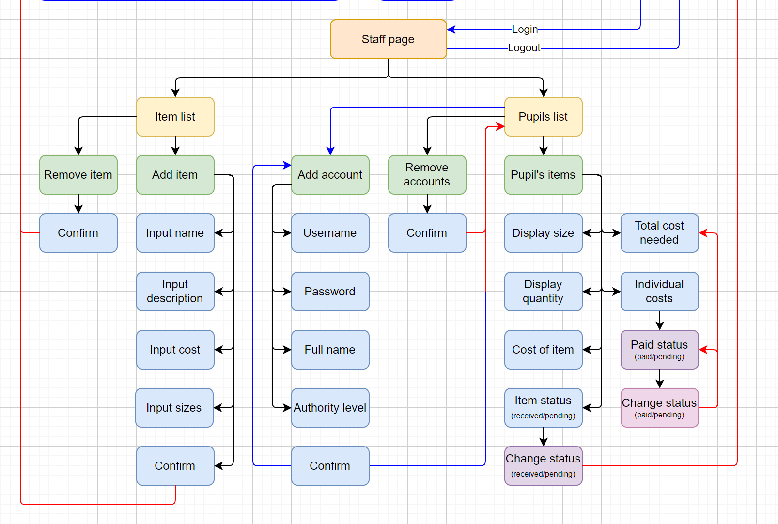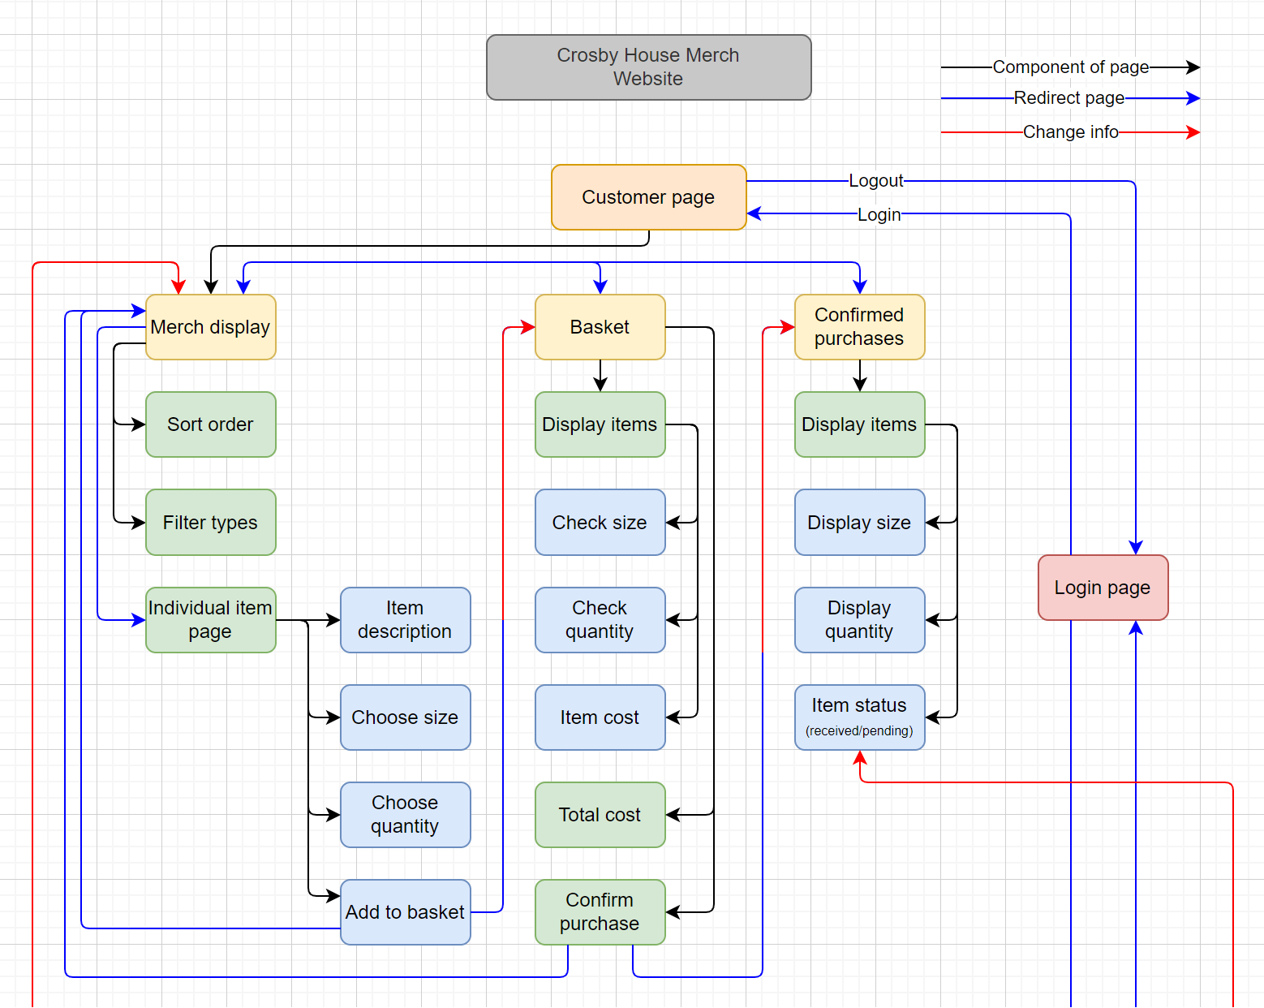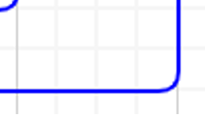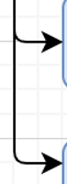

## Entity Relationship Diagram

## Tables

Table Users:

|  |  |  |  |  |
| --- | --- | --- | --- | --- |
| Field Name | Data Type | Validation | Typical Data | Justification |
| UserID | INT(4) UNSIGNED AUTO_INCREMENT PRIMARY KEY |  |  |  |
| Firstname | VARCHAR(30) |  |  |  |
| Lastname | VARCHAR(30) |  |  |  |
| Username | VARCHAR(40) |  |  |  |
| Password | VARCHAR(25) |  |  |  |
| Authority | TINYINT(1) |  |  |  |

Table Order:

|  |  |  |  |  |
| --- | --- | --- | --- | --- |
| Field Name | Data Type | Validation | Typical Data | Justification |
| UserID |  |  |  |  |
| OrderID |  |  |  |  |

Table Order Contents:

|  |  |  |  |  |
| --- | --- | --- | --- | --- |
| Field Name | Data Type | Validation | Typical Data | Justification |
| OrderID | INT(6) UNSIGNED AUTO_INCREMENT PRIMARY KEY |  |  |  |
| Item ID | INT(4) UNSIGNED AUTO_INCREMENT FOREIGN KEY |  |  |  |
| ItemSize |  |  |  |  |
| ItemQuantity |  |  |  |  |
| TotalCost |  |  |  |  |

Table Items:

|  |  |  |  |  |
| --- | --- | --- | --- | --- |
| Field Name | Data Type | Validation | Typical Data | Justification |
| ItemID | INT(4) UNSIGNED AUTO_INCREMENT PRIMARY KEY |  |  |  |
| ItemName | VARCHAR(20) |  |  |  |
| ItemDescription | VARCHAR(500) |  |  |  |
| ItemType |  |  |  |  |
| ItemCost |  |  |  |  |
| PicFront |  |  |  |  |
| PicBack |  |  |  |  |

# Development

# Testing

# Evaluation